https://www.instagram.com/reels/C0hX4uON8EU/
Radio. Presence. Acri.
tmw_radiosport TMW Radio Sport 7,391 posts 10K followers 1,355 following Radio station La radio di @tuttomercatoweb_com 📻 📞331 820 0213 💻 Streaming sul sito 📲 Scaricate l’app www.tmwradio.com
make it more clear
communicate the name of an Agency (nowhere written about what MTA means)
- would you know how well this agency is doing?
How can we find this out?
2. prepare an html file of auditing this site (the data you have above)
in a same style as here
3. brief me on good practice for web-sites auditing. and best recent AEO optimisation trends. do you think it could be a valid service of a high demand
You update Okay. What we have done Today And what we will do today? Make now a small excel or csv file. And with that we will We will Save the session of today later. Sure
- dir to be: verify server.py,
from flask import Flask, request, jsonify
from flask_cors import CORS
from dotenv import load_dotenv
import os
import requests
load_dotenv()
app = Flask(__name__)
CORS(app) If this is how the final file should look like, then you should have just told me to write all that piece. In turn, as complete Not Line by line.
he exact landing-page widget HTML/CSS/JS code with avatar, welcome state, placeholders, and quick replies
the exact mobile hamburger patch for the Netlify landing page

- Why previously before correcting the generic answers of Alessia to the new prompt of the chatbot, connecthat was working and now the 5000 port is not working.
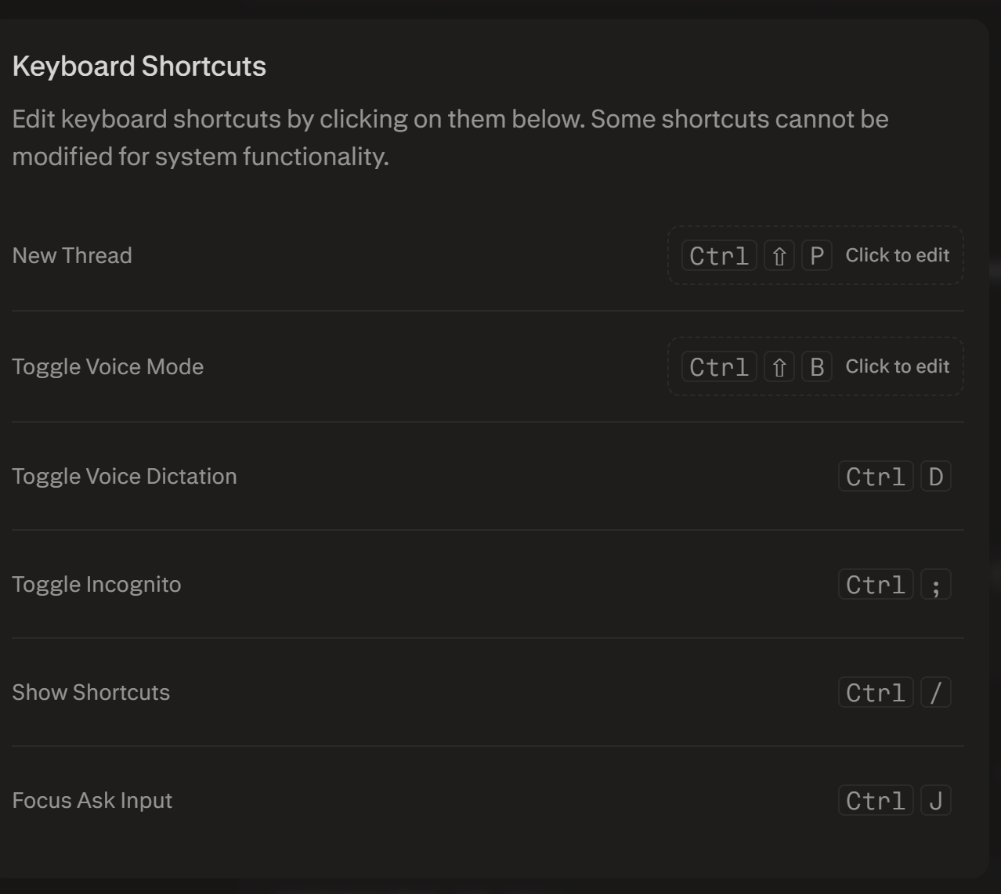or the next project, it is usually better to keep one master MD file for workflow + prompts, and one live tracker CSV for status/decisions/fixes, instead of scattering everything across many prompt files. That reduces version confusion and makes debugging updates easier to track.
Direct answers
Define scope narrowly: yes, LexFlow did this well; that is one of the main reasons the MVP became real instead of bloated.
Lock runtime port early: yes, say it explicitly in Prompt 1, because that is when the app skeleton is first created. Repeat it later only if the tool starts drifting or rewriting the runtime block.
Build in small prompts: yes; the P1–P5 structure worked and should become your reusable pattern.
Master MD vs many TXT files: best default is one master MD as source of truth, with separate .txt prompts only when you actively need copy-paste files for a tool.
Files created
I generated and shared these amended files based on what we learned here:
MASTER_WORKFLOW_Amended.md
launch_tracker_amended.csv
What changed in the amended version
The new workflow explicitly bakes in these lessons:
put runtime rules in Prompt 1,
keep one master source of truth,
avoid multiple overlapping ZIP bundles,
update the tracker immediately after debugging/corrections,
use a reusable P1–P8 prompt structure for future projects.
Recommended pattern for next project
Use this structure:
P1 — skeleton + runtime rules + folder structure
P2 — core form/input flow
P3 — admin/internal view
P4 — client/public view
P5 — files/integrations
P6 — demo data + polish
P7 — UI refinement/theme system
P8 — deploy + verification
Next step
Open MASTER_WORKFLOW_Amended.md first and use it as the template for your next MVP.

